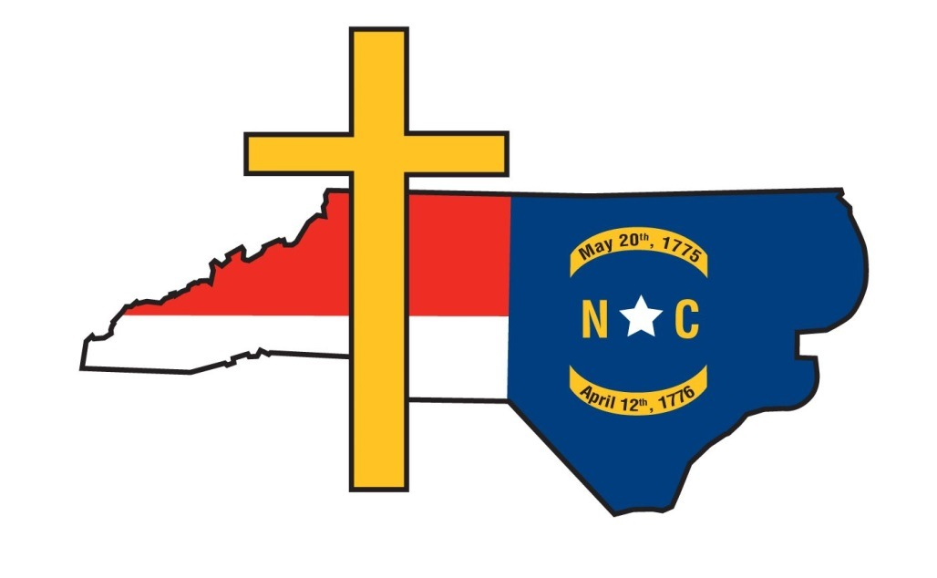

Resolution on Sunday Brunch Bill Ordinances___

Whereas, the North Carolina General Assembly passed legislation in 2017 (SB 155-ABC Omnibus Legislation) that the media dubbed as the “Brunch Bill;” and

Whereas, North Carolina Governor Roy Cooper signed the measure into law on June 30th of the same year, authorizing county commissioners, town and city councils to allow bars, hotels, private clubs, restaurants and retail outlets to roll back the time for the start of alcohol sales on Sundays from noon to 10 a.m.; and

Whereas, local governing bodies must first pass an ordinance that allows for the earlier sales of alcohol on the Lord’s Day to begin; and

Whereas, studies by the American Journal of Preventive Medicine, the Centers for Disease Control and Prevention and social services authorities show extending the sale of alcoholic beverages by two or more hours increases alcohol consumption and its subsequent harms; and

Whereas, researchers conducted a study on the impact of the repeal of a Sunday alcohol sales ban in New Mexico and found that alcohol-related vehicle crashes rose 29% and alcohol-related crash fatalities jumped 42% between 1990 and 2000; and

Whereas, researchers Jung Lee and Baris Yoruk in Does Legalization of Sunday Alcohol Sales Increase Crime? provided by the Center for Economic Studies demonstrate that the repeal of the ban on Sunday alcohol sales in particular states resulted in 13% to 20% increases in the number of violent and property crimes committed on Sundays; and,

Whereas, in McGowan v. Maryland (1961), the United States Supreme Court ruled that Blue Laws are not unconstitutional just because they arise from religious underpinnings, and Sunday laws prohibiting commerce in certain instances are of a secular purpose rather than a religious one; and,

Whereas, in Zorach v. Clauson (1952) the United States Supreme Court ruled that “[w]hen the State encourages religious instruction or cooperates with religious authorities by adjusting the schedule of public events to sectarian needs, it follows the best of our traditions”… respecting “the religious nature of our people” and accommodating “the public service to their spiritual needs;” and,

Whereas, in the study, provided by the National Bureau of Economic Research, titled The Church vs. the Mall: What Happens When Religion Faces Increased Secular Competition, authors Jonathan Gruber and Daniel M. Hungerman found that when a state repeals its Blue Laws religious attendance falls, and that church donations and spending fall too; and,

Whereas, lawmakers and other public officials are sensitive to rejecting legislative initiatives counterproductive to a flourishing business environment, and churches need a similar sensitivity that resists public policies that work against religion’s optimum opportunity for a positive impact on the culture, and Sunday Brunch Ordinances negatively impact religious influence; and,

Whereas, Sunday Brunch Ordinances reveal a tacit disrespect for churches and their role in serving those victimized by alcohol abuse in that they exacerbate the very harms the church is working diligently to heal, even adding insult to these injuries by increasing the sale of alcoholic beverages during the church’s primary meeting time; and,

Whereas, the services churches provide, which are free and effective, save taxpayer dollars that might otherwise be employed by the state in social services and public assistance programs;

THEREFORE BE IT RESOLVED that ________________________ earnestly calls upon the ____________________________ to reject any Sunday Brunch Ordinance initiative, recognizing its approval would increase alcohol related harms in _____________________________, and the state of North Carolina, while also negatively impacting the indispensable services of churches in its community and religious influence in general.

*This proposed resolution is provided by the Christian Action League of North Carolina Inc., 809 Spring Forest Road, Raleigh, NC, 27609.

Religious groups, churches, denominations or denominational agencies may amend the resolution to suit their needs in opposing Sunday Brunch Ordinances. No attribution to the Christian Action League is required.

